## A logo of a university AI-generated content may be incorrect. East West University

**Department of Computer Science and Engineering**

## A/2, Jahurul Islam Avenue, Jahurul Islam City, Aftabnagar, Dhaka

**Course Code:**

CSE405 (Networking Lab)

**Course Instructor:**

Rabea Khatun, Lecturer, CSE

## Title: **Network Address Translation**

## Objective(s)

* To configure NAT on network devices to facilitate seamless communication between internal and external networks while conserving public IP addresses.

## Problem analysis

### Basic Overview of NAT

There are several situations where we need address translation such as, a network which do not have sufficient public IP addresses want to connect with the Internet, two networks which have same IP addresses want to merge or due to security reason a network want to hide its internal IP structure from the external world. NAT (Network Address Translation) is the process which translates IP address. NAT can be performed at firewall, server and router.

### NAT Terminology

Before we understand NAT in details let’s get familiar with four basic terms used in NAT.

|  |  |
| --- | --- |
| Term | Description |
| Inside Local IP Address | An IP address that is assigned to a host  on the Inside (local) network. The address is probably not an IP address assigned by the service provider i.e., these are private IP addresses. This is the inside host seen from the inside network. |
| Inside Global IP Address | IP address that represents one or more  inside local IP addresses to the outside world. This is the inside host as seen from the outside network. |
| Outside Global IP Address | This is the actual IP address of the  destination host in the local network after translation. |
| Outside Local IP Address | This is the outside host as seen from the  outside network. It is the IP address of the outside destination host before translation. |

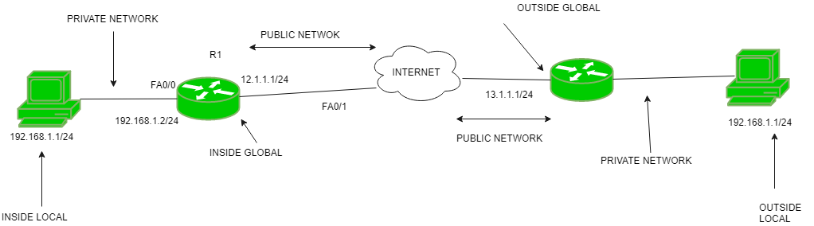

Figure 1: Network Address Translation Structure

### Types of NAT

**Static NAT**

In this type we manually map each inside local IP address with inside global IP address. Since this type uses one to one mapping we need exactly same number of IP address on both sides.

**Dynamic NAT**

In this type we create a pool of inside global IP addresses and let the NAT device to map inside local IP address with the available outside global IP address from the pool automatically.

**PAT**

In this type a single inside global IP address is mapped with multiple inside local IP addresses using the source port address. This is also known as PAT (Port Address Translation) or NAT over load.

## Implementing Static NAT

1. Create a network topology as Figure 1 in Cisco Packet Tracer and configure initial IP addresses.

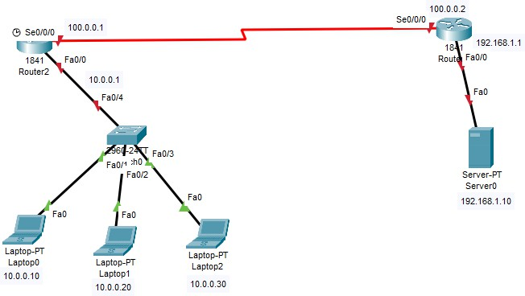

Figure 2: Build the network

1. To assign IP address in Laptop and server, click Laptop/server and click Desktop and IP configuration and Select Static and set IP address as given in figure 1.
2. Perform static routing for Router 1 and Router 2. As shown in fig.3
3. Since static NAT use manual translation, we have to map each inside local IP address (which needs a translation) with inside global IP address. Following command is used to map the inside local IP address with inside global IP address.

ip nat inside source static [inside local ip address] [inside global IP address]

For example in our lab Laptop0 is configured with IP address 10.0.0.10. To map it with 50.0.0.10 IP address we will use following steps-

Click Router1 and select CLI and press ENTER and finally write following commands-

Similarly for Laptop1, map 10.0.0.20 with 50.0.0.20 and for Laptop2, map 10.0.0.30 with 50.0.0.30. Also, For Server0, map 192.168.1.10 with 200.0.0.10.

1. **Testing Static NAT Configuration** In this lab we configured static NAT on R1 and R2. On R1 we mapped inside local IP address 10.0.0.10 with inside global address 50.0.0.10 while on R2 we mapped inside local IP address 192.168.1.10 with inside global IP address 200.0.0.10.

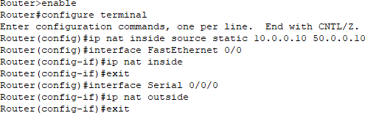

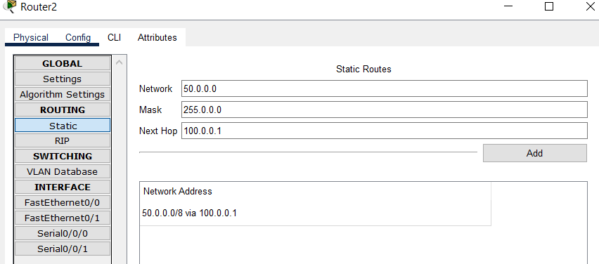

Figure 3: Routing

|  |  |  |
| --- | --- | --- |
| Device | Inside Local IP Address | Inside Global IP Address |
| Laptop0 | 10.0.0.10 | 50.0.0.10 |
| Server | 192.168.1.10 | 200.0.0.10 |

To test the setup click Laptop0 and Desktop and click Command Prompt and Run ping 200.0.0.10 com- mand and ping 192.168.1.10 command.

First command checks whether we are able to access the remote device or not. A ping reply confirms that we are able to connect with remote device on this IP address. Second command checks whether we are able to access the remote device on its actual IP address or not. A ping error confirms that we are not able to connect with remote device on this IP address.

## Discussion & Conclusion

Based on the focused objective(s) to learn the step-by-step configuration of static network address translation. The NAT is used for translating public and private ip address. The additional lab exercise will help us to be confident towards the fulfilment of the objectives(s).

## Lab Task (Please implement yourself and show the output to the instructor)

The purpose of this exercise is to configure NAT on the source router (NAT inside source) and test for connec- tivity by pinging a remote router.

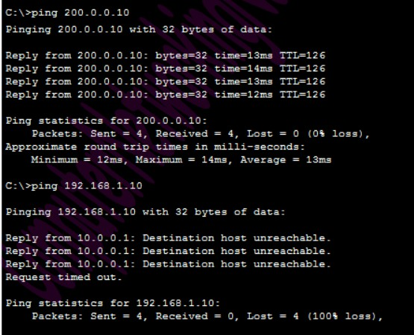

Figure 4: Test

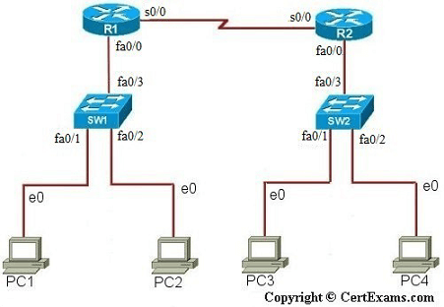

**IP Address Assignment Table**

|  |  |  |  |
| --- | --- | --- | --- |
| Device | Interface | IP Address | Mask |
| R1 | S0/0 & Fa0/0 | 200.200.200.1 &  192.168.1.13 | 255.255.255.0 &  255.255.0.0 |
| R2 | S0/0 & Fa0/0 | 200.200.200.2 &  10.1.1.4 | 255.255.255.0 &  255.0.0.0 |
| PC1 |  | 192.168.1.10 | 255.255.0.0 |
| PC2 |  | 192.168.1.11 | 255.255.0.0 |
| PC3 |  | 10.1.1.1 | 2255.0.0.0 |
| PC4 |  | 10.1.1.2 | 255.0.0.0 |
| SW1 |  | 192.168.1.12 | 255.255.0.0 |
| SW2 |  | 10.1.1.3 | 255.0.0.0 |

**NAT Mapping Table for Inside Source**

|  |  |
| --- | --- |
| Inside Local | Inside Global |
| 192.168.1.10 | 200.200.200.3 |
| 192.168.1.11 | 200.200.200.4 |

**Instructions:**

1. Assign IP addresses on all the devices as per the above table
2. Enable static routing on all routers.
3. Create IP NAT Mapping (Hint: use inside source static command) on R1
4. Define IP NAT Inside and IP NAT Outside on R1
5. Test for Connectivity from PC1 to R2 by issuing ping command

## Lab Exercise (Submit as a report)

Write a lab report on Configuring Dynamic NAT in Cisco Router. The lab report will be given in the next class.

## Policy

Copying from internet, classmate, seniors, or from any other source is strongly prohibited. 100% marks will be

*deducted* if any such copying is detected.